**Cassandra DB, Can I do complex filtering? ( same as Advance Filter or Group Advance filter in Search Service**

**Advance filter Supported Operators**

| Operators that search service supports | Operators of cassandra |
| --- | --- |
| equal | = |
| not_equal | Not support |
| contains | Contains |
| does_not_contain | Not support |
| Starts_with | We can use LIKE but LIKE queries can be achieved using a SSTable Attached Secondary Index (SASI). |
| is_between | We can use LIKE but LIKE queries can be achieved using a SSTable Attached Secondary Index (SASI). |
| is_between_or_equal_to | We can use LIKE but LIKE queries can be achieved using a SSTable Attached Secondary Index (SASI). |
| greater_than_equal | <= |
| is_greater_than | < |
| less_than_equal | >= |
| is_less_than | > |
| is_not_between | doesn’t support |
| is_not _empty | doesn’t support |
| is_empty | =‘’ |



it support these operators '=' | '<' | '>' | '<=' | '>=' | IN | CONTAINS | CONTAINS KEY and arithmetic operators

Cassandra do support '!=' as a operator but not in select query for search it only work with 'IF' statement in insert/update i have test it by myself as well it is working fine with 'IF'

References

<https://user.cassandra.apache.narkive.com/kJVo9Fbr/not-equals-in-where-clause>

<https://github.com/scylladb/scylladb/issues/4287>

and yes it does work with is_not_empty but with this way

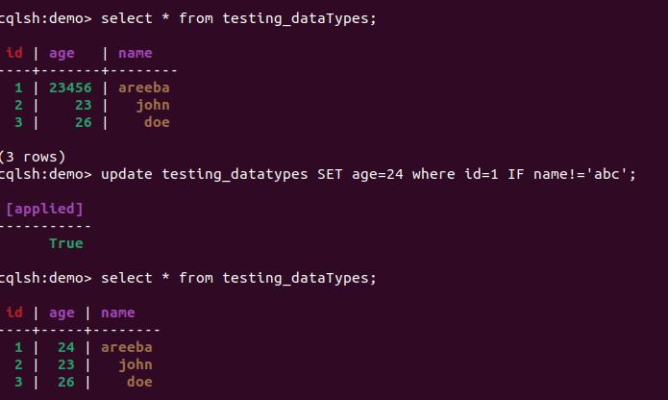

Why doesn't it support ‘!=’

If we look at Cassandra architecture Cassandra distributes data across multiple nodes based on the partition key. Each node is responsible for storing and handling a specific range of partition keys. To efficiently retrieve data, Cassandra requires a query to target a specific partition or a range of partitions. The "!=" operator would require scanning all partitions to check for inequality, which is not ideal for the distributed nature of Cassandra.which could result in inefficient and slow queries just like range we cannot apply range on our partition key

<https://stackoverflow.com/questions/75345877/is-it-possible-to-express-inequality-in-the-where-clause-of-a-cql-statement>

<https://cassandra.apache.org/doc/4.0/cassandra/cql/changes.html>